**Orientation**

**Information about the Key Pin and Name Tag**

Key Pin: Example Name Tag:

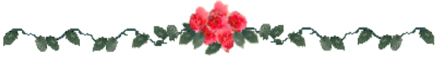The wreath of laurel leaves signify honor, the cup signifies knowledge and the Greek letters DKG signify key women educators.

**Amount Due on September 5, 2019:**

Annual Dues $85.00

Key Pin: 14.25

Shipping 7.75

(divided among inductees)

Name Tag: 7.00

Shipping 3.00

(divided among inductees)

Induction Fee: 10.00

**Total $116.25 plus shipping**

**Just for your information:**

We get our name tags from

B & T Trophies

862 Julian Allsbrook Dr.

Roanoke Rapids, NC 27870

252-537-3070

We call each year to get the price (usually 6.50 plus 7% tax plus 3.00 shipping). We then send a sample picture of what we want on the name tag, a list of names, and a check for the amount. We request a magnetic clasp. They mail

the name tags to us.